7.83: a) Along this line, 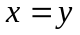, so 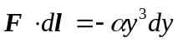, and
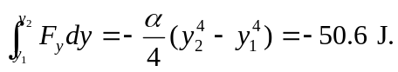
b) Along the first leg, 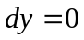 and so 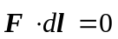. Along the second leg, 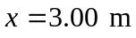, so 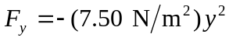, and
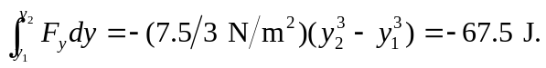
c) The work done depends on the path, and the force is not conservative.

